September 21, 21, 1946 One Town for itself
FLZ #31
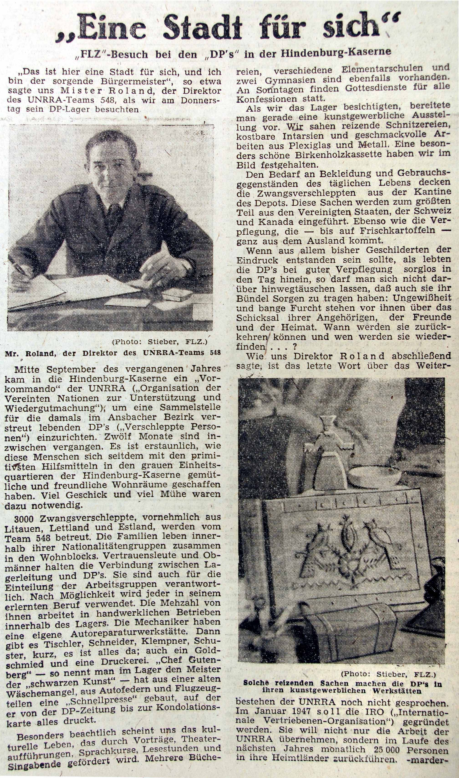
side 7
Frånische
Landeszeitung

In English:

Note to readers: The following is a computer translation of the above article. If anyone wants to do a better translation job of this article, please submit to okaczmar@gmail.com

Here is a city for itself, and I am the ensuring Mayor, so said to us Mister Roland, the director of the UNRRA team 548, when we visited DP camps on Thursday. In the middle of September of last year, a Head commander of the UNRRA organization of the United Nations took over the Hindenburg barracks with support and compensation, in order to establish a collection point, because at that time kidnapped persons/DP's were living scattered in the Ansbach district. Twelve months have passed since. It is amazing, what these humans created for themselves since then, with the primitive stone aids in the grey unit accommodations of the cozy Hindenburg camp and friendly dwellings. Much fate and much trouble were necessary for it.

3000 persons kidnapped by force, primarily from Lithuania, Latvia and Baltic states, are cared for by the Team 548. The families live in their nationality groups together in the blocks of flats. Security people and Chairman hold the connection between camp line and DP's. They are also responsible for the organization of the working groups. All uses their learned occupation. The majority of them work in enterprises relating to crafts internally necessary in the camp. The mechanics have their own. Then there is a carpenter, cutter, plumber, shoemaker; soon everything is there; also a goldsmith and a printer. One man, called Chef Gutenburg, is the master of the "black art," a high-speed printing machine in the camp, built from old parts of washing machine, automobile springs and airplane parts, on which he prints the DP newspaper and everything else. Cultural life has grown considerably, through lectures, theatres performances, and language courses. Reading hours and singing evenings are promoted. Several bookstores, different elementary schools and two high schools are also present. On Sundays services take place for all denominations. When we visited the camp, someone prepared an art and crafts exhibition. We saw attractive carvings, precious inlays and tasteful work from Plexiglas and metal. One particularly nice Birkenholz cartridge we held in the picture.

The need for clothing and materials for the daily life needed by the forced-kidnapped comes out of the cafeteria of the depots. These things come the mainly from the United States, Switzerland and Canada. Just as the food supply, such as fresh potatoes, comes completely from foreign countries.

From all so far described, if the impression is that the DP's live carelessly with good food supply into the day inside, then one may not fiber to be away-exchanged be able that also they have to carry their bundle concerns; uncertainty and fears for fear stands forwards more about the fate of their one's belonging, the friends more under the homeland. When will they return, to whom can they turn and when will they find their way again...

When we asked Director Roland what was the final word and he said to us finally, thus far UNRRA has not spoken. In January 1947 the IRO (International Relief Organization) is to be placed into position. It not only wants to do the work of the UNRRA, but will take a separate course in the next year to return 25,000 persons monthly to their native land.

